5th Grade Units Studies
Name_________________#___Date_________________
- 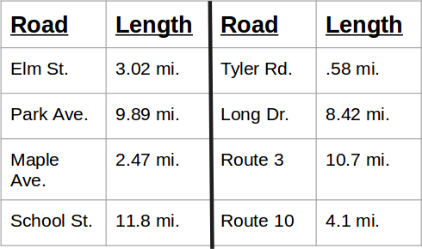
The road crew had enough asphalt in their truck to repair 25 miles of road. Many roads in town needed work and this truckload would only do part of the job. Look at this list of roads and their lengths and create a list for the road crew to pave with this truckload. Round each value to the nearest whole number to make an estimate for the crew. (Try to use all the asphalt, the boss prefers they try to use the entire load on each trip.)
- Emma is shopping at her favorite mall for a special outfit for the dance. She has the following items in her basket:
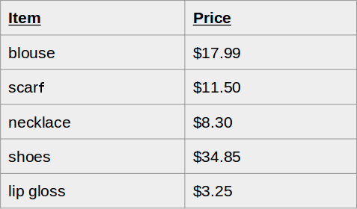
If she buys every item, what is her estimated total to the nearest dollar?
She discovers she only has $60. What item(s) can she put back, but still gets some new clothes?
- Round
Round to the tens
3,578 = ​
60,905 = ​
125,963=
- 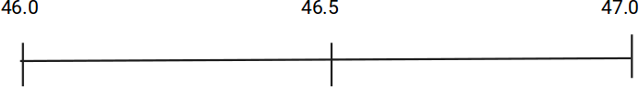
Drag these decimals to the benchmark decimals they are closest to.

46.23
46.49
46.8
- When can rounding decimals be used as an estimation tool?

A. You can round prices at the grocery store to estimate your total.
B. You can estimate the tax you will pay on a shopping trip.
C. You are at a fast food restaurant and you want to make sure you have enough money for your meal choices.
D. All of the above.
- 345.23◯345.230​
- ​22.375◯22.38​
- ​85.1◯85.049​
- ​9.9◯9.900

